GROUP - A

EXPERIMENT NO : 01

Title:

Design suitable data structures and implement pass-I and pass-II of a two-pass assembler for pseudo-machine in Java using object oriented feature. Implementation should consist of a few instructions from each category and few assembler directives. The output of Pass -I should be input for Pass -II.

Theory Concepts

Introduction :-
There are two main classes of programming languages: high level (e.g., C, Pascal) and low level. Assembly Language is a low level programming language. Programmers code symbolic instructions, each of which generates machine instructions.
An assembler is a program that accepts as input an assembly language program (source) and produces its machine language equivalent (object code) along with the information for the loader.
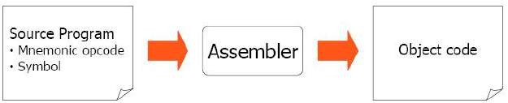

Figure 1. Executable program generation from an assembly source code

Advantages of coding in assembly language are:
- Provides more control over handling particular hardware components
- May generate smaller, more compact executable modules
- Often results in faster execution
•

Disadvantages:
- Not portable
- More complex
- Requires understanding of hardware details (interfaces)

Pass – 1 Assembler:

An assembler does the following:
- Generate machine instructions
  - evaluate the mnemonics to produce their machine code
  - evaluate the symbols, literals, addresses to produce their equivalent machine addresses
  - convert the data constants into their machine representations
- Process pseudo operations
Pass – 2 Assembler:

A two-pass assembler performs two sequential scans over the source code:

Pass 1: symbols and literals are defined
Pass 2: object program is generated
Parsing: moving in program lines to pull out op-codes and operands

Data Structures:

- Location counter (LC): points to the next location where the code will be placed

- Op-code translation table: contains symbolic instructions, their lengths and their op- codes (or subroutine to use for translation)

- Symbol table (ST): contains labels and their values

- String storage buffer (SSB): contains ASCII characters for the strings

- Forward references table (FRT): contains pointer to the string in SSB and offset where its value will be inserted in the object code
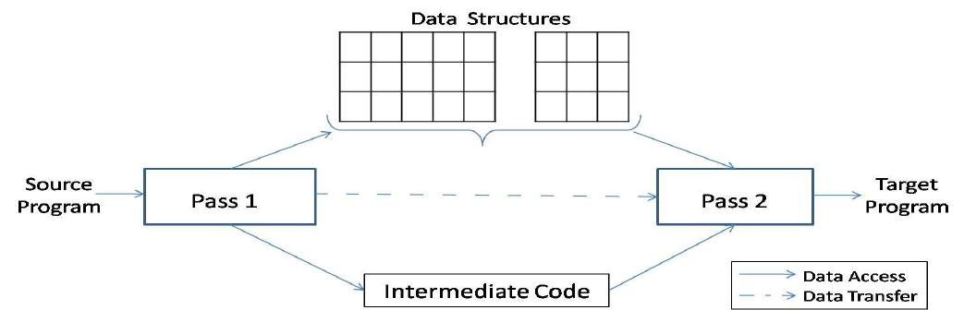

Figure 2. A simple two pass assembler.

Elements of Assembly Language :

An assembly language programming provides three basic features which simplify programming when compared to machine language.

Mnemonic Operation Codes :

Mnemonic operation code / Mnemonic Opcodes for machine instruction eliminates the need to memorize numeric operation codes. It enables assembler to provide helpful error diagnostics. Such as indication of misspelt operation codes.

Symbolic Operands :
Symbolic names can be associated with data or instructions. These symbolic names can be used as operands in assembly statements. The assembeler performes memory bindinding to these names; the programmer need not know any details of the memory bindings performed by the assembler.

Data declarations :

Data can be declared in a variety of notations, including the decimal notation. This avoids manual conversion of constants into their internal machine representation, for example -5 into (11111010)2 or 10.5 into (41A80000)16

Statement format :

An assembly language statement has the following format :
[ Label] <Opcode> <operand Spec> [, operand Spec> ..]
Where the notation [..] indicates that the enclosed specification is optional.
Label associated as a symbolic name with the memory word(s) generated for the statement

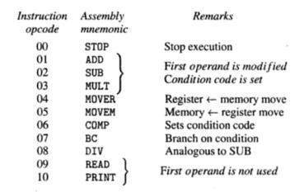
Mnemonic Operation Codes :
Instruction Format :

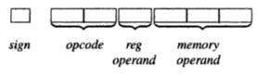

Sign is not a part of Instruction

An Assembly and equivalent machine language program :(solve it properly)

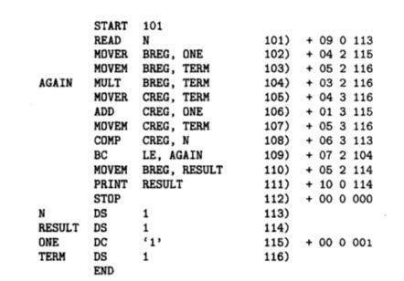

Assembly Language Statements :
Three Kinds of Statements
- Imperative Statements
- Declaration Statements
- Assembler Directives
- Imperative Statements : It indicates an action to be performed during the execution of the assembled program. Each imperative statement typically translates into one machine instruction.
- Declaration Statements : Two types of declaration statements is as follows

[Label] DS [Label] DC
<constant>

‘<Value>’
The DS (Declare Storage) statement reserves areas of memory and associates names with them.

Eg)A | DS | 1
B | DS | 150

First statement reserves a memory of 1 word and associates the name of the memory as A. Second statement reserves a memory of 150 word and associates the name of the memory as B.
The DC (Declare Constant) Statement constructs memory word containing constants. Eg ) ONE DC ‘1’
Associates the name ONE with a memory word containing the value ‘1’ . The programmer can declare constants in decimal,binary, hexadecimal forms etc., These values are not protected by the assembler. In the above assembly language program the value of ONE Can be changed by executing an instruction MOVEM BREG,ONE

Assembler Directives :
Assembler directives instruct the assembler to perform certain actions during the assembly of a program. Some Assembler directives are described in the following

START <Constant>
Indicates that the first word of the target program generated by the assembler should be placed in the memory word with address <Constant>

END [ <operand spec>]
It Indicates the end of the source program

Pass Structure of Assembler :

One complete scan of the source program is known as a pass of a Language Processor. Two types 1) Single Pass Assembler 2) Two Pass Assembler.

Single Pass Assembler :

First type to be developed Most Primitive Source code is processed only once.
The operand field of an instruction containing forward reference is left blank intially Eg) MOVER BREG,ONE
Can be only partially synthesized since ONE is a forward reference

During the scan of the source program, all the symbols will be stored in a table called SYMBOL TABLE. Symbol table consists of two important fields, they are symbol name and address.
All the statements describing forward references will be stored in a table called Table of Incompleted Instructions (TII)

TII (Table of Incomplete instructions)

Instruction Address | Symbol
101 | ONE

By the time the END statement is processed the symbol table would contain the address of all symbols defined in the source program.

Two Pass Assembler :

Can handle forward reference problem easily.
First Phase : (Analysis)
- Symbols are entered in the table called Symbol table
- Mnemonics and the corresponding opcodes are stored in a table called Mnemonic table
- LC Processing
Second Phase : (Synthesis)

  - Synthesis the target form using the address information found in Symbol table.
  - First pass constructs an Intermediated Representation (IR) of the source program for use by the second pass.

Data Structure used during Synthesis Phase :
    - Symbol table
    - Mnemonics table

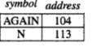
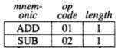

Processed form of the source program called Intermediate Code (IC)
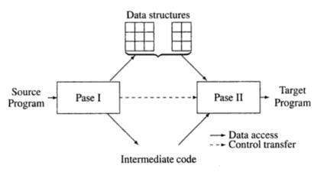

ADVANCED ASSEMBLER DIRECTIVES

- ORIGIN
- EQU
- LTROG

ORIGIN :

Syntax : ORIGIN < address spec>

< address spec>can be an <operand spec> or constant

Indicates that Location counter should be set to the address given by < address spec>
This statement is useful when the target program does not consist of consecutive memory words. Eg) ORIGIN Loop + 2
EQU : Syntax

<symbol> EQU <address spec>

<address spec>operand spec (or) constant
Simply associates the name symbol with address specification No Location counter processing is implied
Eg ) Back EQU Loop LTORG : (Literal Origin)
Where should the assembler place literals ?
It should be placed such that the control never reaches it during the execution of a program.
By default, the assembler places the literals after the END statement.
LTROG statement permits a programmer to specify where literals should be placed.

DESIGN OF TWO PASS ASSEMBLER:

Pass I : (Analysis of Source Program)

- Separate the symbol, mnemonic opcode and operand fields
- Build the symbol table.
- Perform LC processing.
- Construct intermediate representation

PASS 2:-

Processes the intermediate representation (IR) to synthesize the target program.

Note :(you can also write your own theory for this practical)

Solve the below example.for Pass-1 Assembler.
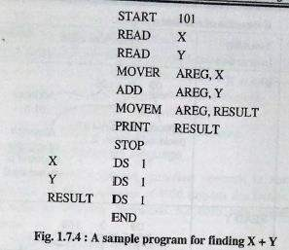

Conclusion :

Thus , I have implemented Pass-1 & Pass -II assembler with symbol table, literal table,pool table and Machine Opcode Table .

